Impact of calcium doping on the electronic and optical characteristics of strontium hydride (SrH₂): A DFT Study

Hamza Errahoui¹*, Mohamed Karouchi ¹, Abdelkebir Ejjabli ¹, Aymene Elhaji ¹, Abdelmounaim Laassouli ¹, Youssef Lachtioui ¹, Omar Bajjou ¹

¹ Laboratory of Engineering in Chemistry and Physics of Matter Faculty
of Sciences and Technics,Sultan Moulay Slimane University, BP 523, 23000, Beni Mellal, Morocco.
*Email : hamzaa.errahoui@gmail.com

Abstract. This study investigates the electronic and optical properties of calcium-doped strontium hydride (SrH₂) using first-principles density functional theory (DFT) calculations via the CASTEP code with the generalized gradient approximation (GGA). We explore the impact of calcium (Ca) doping on the electronic band structure, density of states (DOS), and optical absorption spectra of SrH₂. Our results show that Ca doping significantly alters the electronic properties, notably increasing the indirect bandgap from 1.3 eV to 1.6 eV. The DOS analysis reveals new states near the Fermi level, primarily from Ca 3d orbitals. Moreover, the optical absorption spectra display enhanced absorption in the visible range, suggesting potential for optoelectronic applications. This research highlights the feasibility of tuning the electronic and optical characteristics of SrH₂ through Ca doping, opening the way for advanced materials with tailored properties.

1.Introduction
Alkaline earth hydrides (AH₂) are considered promising candidates for hydrogen energy and thermal energy storage applications. Among these, heavy alkaline earth hydrides (HAEHs), particularly those of calcium (Ca), strontium (Sr), and barium (Ba), have emerged as a promising class of materials owing to their potential applications in hydrogen storage, fuel cells, and thermal energy storage. These materials are of particular interest due to their exceptional ionic conductivity and favorable thermal stability. Heavy alkaline earth hydrides (HAEH, A = Ca, Sr, and Ba) have emerged as a promising class of materials due to their potential applications in hydrogen storage, fuel cells, and thermal energy storage.
The chemistry of heavy alkaline earth hydrides (HAEHs) was initially explored in 1935, where it was discovered that these compounds crystallize in an orthorhombic crystal structure with the Pnma space group. Despite this breakthrough, the exact atomic positions of hydrogen within these structures remained uncertain. For instance, "Hydrolith," or calcium hydride (CaH₂), a well-known hydrogen source, crystallizes in the cotunnite structure (Pnma) under ambient conditions. Subsequent studies by Bergsma and Loopstra provided optimized crystal structures for CaD₂ and CaH₂ through neutron diffraction, successfully identifying the correct positions of hydrogen atoms within these compounds. Further investigations utilizing neutron diffraction and nuclear magnetic resonance (NMR) studies on CaD₂ and CaH₂ [22] refined the hydrogen atomic positions within these structures. Additionally, techniques such as inelastic neutron scattering (INS) and neutron vibrational spectroscopy were employed to determine the crystal structures of calcium hydride and deuteride. Neutron diffraction studies of strontium deuteride (SrD₂), conducted by Brese et al. in 1990 [25], revealed significantly different hydrogen positions, which were later corroborated and refined by Sichla and Jacobs [26]. Alkaline earth metal hydrides continue to be regarded as promising materials for hydrogen storage and optoelectronic applications. In particular, strontium hydride (SrH₂) has drawn attention due to its favorable thermodynamic properties, high hydrogen storage capacity, and wide bandgap. However, the wide bandgap of pristine SrH₂ limits its potential in optoelectronics, especially in the visible light region. Doping with suitable elements has emerged as an effective strategy to modify the electronic structure and enhance the optical properties of various materials.
Calcium (Ca), an alkaline earth metal with ionic radii and electronic configuration similar to that of strontium (Sr), emerges as a promising dopant for strontium hydride (SrH₂). Previous research on calcium-doped strontium titanate (SrTiO₃) has demonstrated the effectiveness of Ca doping in altering the electronic structure and enhancing the photocatalytic activity of the material. Building on these findings, a comprehensive theoretical investigation utilizing density functional theory (DFT) was undertaken to assess the impact of Ca doping on the electronic and optical properties of SrH₂. Numerous experimental and theoretical investigations have been conducted to elucidate the structural and electronic properties of alkaline earth metal hydrides. First-principles studies by El-Gridani on CaH₂ [27, 28], SrH₂ [29], and BaH₂ [30], utilizing the Hartree-Fock or pseudopotential methods within the framework of the CRYSTAL95 program, have confirmed prior results. Additionally, Smithson [31] employed density functional theory (DFT)-based methods to investigate the stability and electronic structure of various metal hydrides. This investigation aims to thoroughly elucidate the effects of calcium (Ca) doping on the electronic band structure, density of states, absorption coefficient, dielectric function, and other pertinent optical properties of strontium hydride (SrH₂). The findings of this study will both elucidate the fundamental properties of doped SrH₂ and facilitate its prospective integration into optoelectronic and energy-related applications.

2. Computational Methods
First-principles calculations were conducted using density functional theory (DFT) within the CASTEP code framework [9]. Exchange-correlation interactions were modeled with the $Perdew-Burke-Ernzerhof (PBE)$ functional, employing the generalized gradient approximation $(GGA)$ [10]. $OTFG ultrasoft pseudopotentials$ [11] were used to represent the interactions between ionic cores and valence electrons. Plane-wave basis sets with a cutoff energy of 500 eV were applied to expand the electronic wavefunctions. Brillouin zone integrations were performed using a $6×6×6$ $Monkhorst-Pack k-poin$t mesh for structural optimization, along with electronic and optical property calculations.
The structure of SrH₂ was initially optimized until the forces on each atom were reduced to below 0.05 eV/Å. To ensure a thorough investigation of the material's properties, the supercell of SrH₂, which adopts a hexagonal structure, was expanded by doubling the lattice parameters in both the X and Y directions before doping. Following this, one Sr atom was substituted with a Ca atom, resulting in a doping concentration of 12.5%. The electronic and optical properties of both pristine and Ca-doped SrH₂ were then calculated using the optimized structures. There are two distinct H¹⁻ sites present. In the first H¹⁻ site, H¹⁻ is bonded to five equivalent Sr²⁺ atoms, forming HSr₅ trigonal bipyramids. These bipyramids share corners with twelve equivalent HSr₆ octahedra, corners with eight equivalent HSr₅ trigonal bipyramids, edges with six equivalent HSr₅ trigonal bipyramids, and faces with six equivalent HSr₆ octahedra. The tilt angles of the corner-sharing octahedra range from 31° to 59°. In the second H¹⁻ site, H¹⁻ is bonded to six equivalent Sr²⁺ atoms, forming HSr₆ octahedra. These octahedra share faces with two equivalent HSr₆ octahedra and faces with six equivalent HSr₅ trigonal bipyramids. The tilt angles of the corner-sharing octahedra are 51°. Atomic positions and lattice parameters for SrH₂ are detailed in Tables 1 and 2, respectively

Table 1 : Atomic Positions
Wyckoff | Element | x | y | z
2a | H | 0 | 0 | 0
2c | Sr | 2/3 | 1/3 | 3/4
2d | H | 2/3 | 1/3 | 1/4

Table 2 :Lattice parameters
a | 4.12 Å
b | 4.12 Å
c | 5.68 Å
α | 90.00 º
β | 90.00 º
ɣ | 120.00 º
Volume | 83.51 Å³
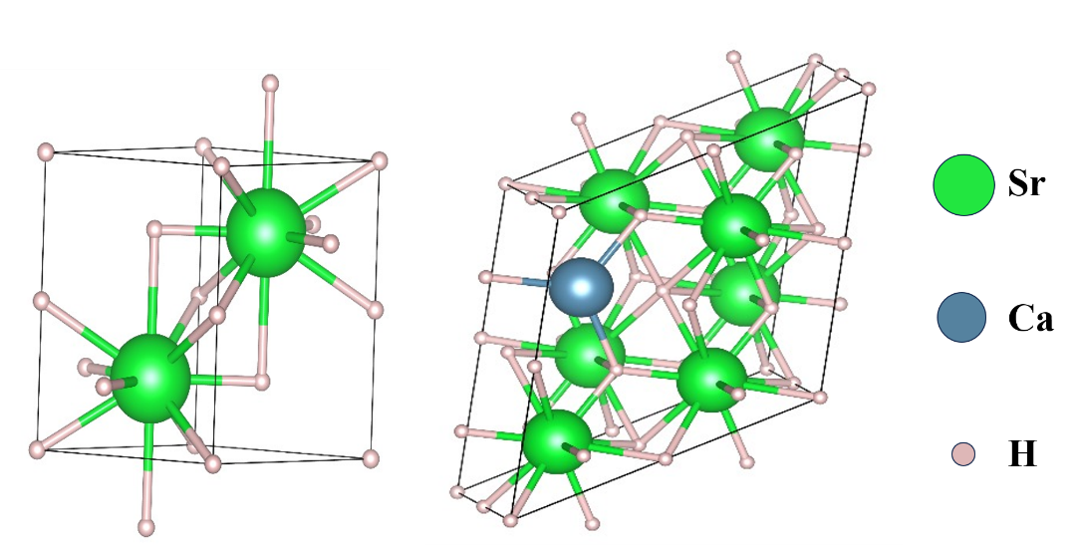

Fig 1: Crystal structure of a) pristine and b) Ca-doped SrH₂

3. Results and Discussions
3.1 Electronic Properties(Band Structure and Density of States)

This subsection presents a comparative analysis of the band structure and density of states (DOS) for both pristine SrH₂ and Ca-doped SrH₂. The band structure analysis elucidates the impacts of calcium doping on electronic band dispersion and energy gaps, which are crucial for understanding alterations in electronic behavior. Simultaneously, the DOS analysis reveals the distribution of electronic states across various energy levels, providing insights into how doping influences the material's electronic density. Collectively, these analyses enhance the comprehension of the electronic properties and potential applications of SrH₂, highlighting the impact of doping on its electronic characteristics. The calculated electronic band structures and density of states (DOS) for both pristine and Ca-doped SrH₂ are illustrated in Figure 2(a) and Figure 2(b), respectively. Pristine SrH₂ exhibits an indirect band gap of 1.3 eV at the H-G point. Following Ca-doping, the band gap increases to 1.6 eV, resulting in a decrease in the material's conductivity. This increase in the band gap is attributed to the introduction of Ca-3d states above the valence band maximum (VBM) of SrH₂, as indicated by the DOS plots

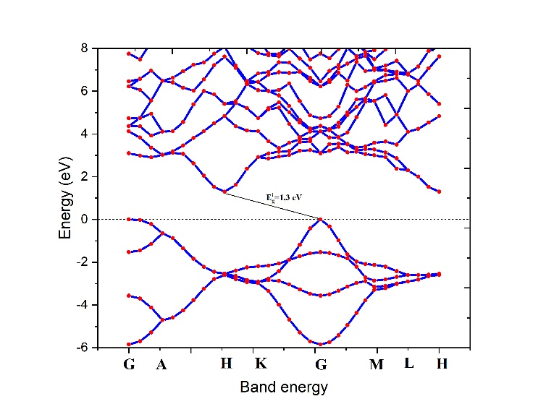
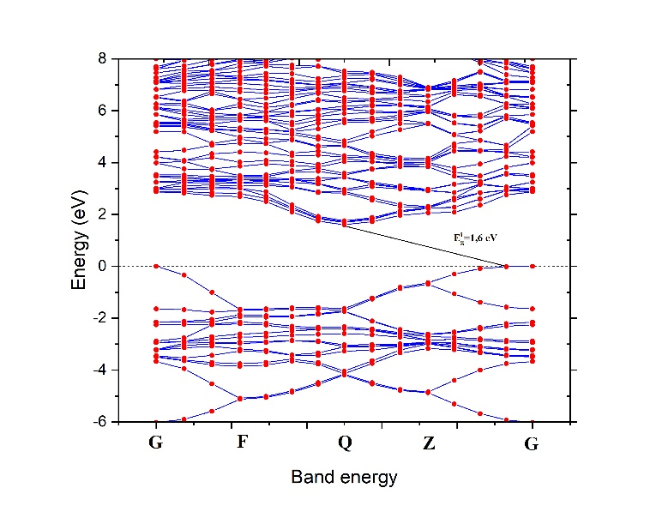
(b)
(a)

Fig 2: Band structures of a) pristine and b) Ca-doped SrH₂

(a)
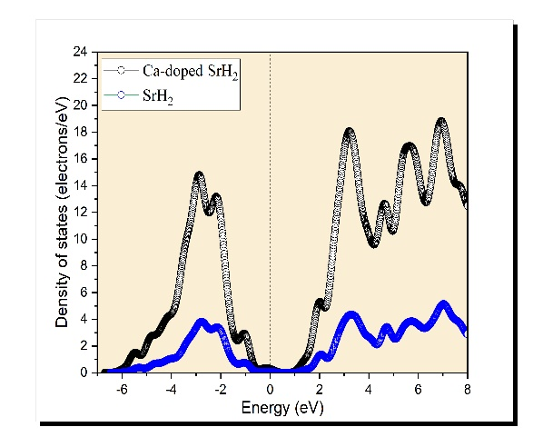

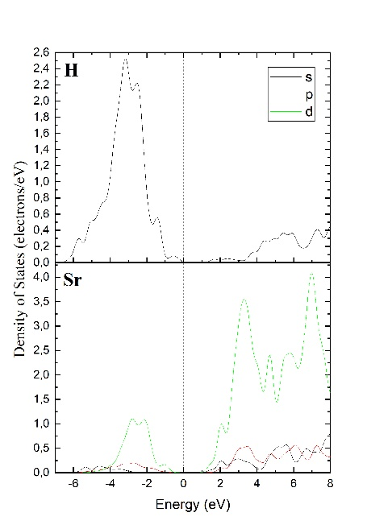
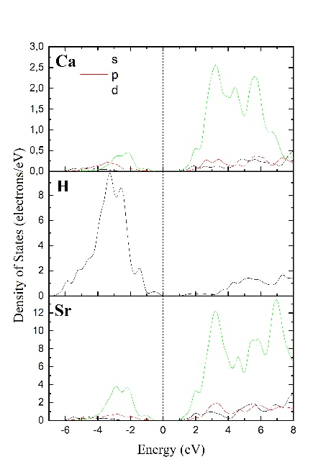
(c)
(b)

Fig 3: a) DOS of pristine and Ca-doped SrH₂, PDOS b) Pristine SrH₂ c) Ca-doped SrH₂

Figure 3(a-c) presents the total and partial density of states (DOS) for both pristine and Ca-doped SrH₂. Calcium doping induces significant changes in the electronic structure of SrH₂, which are particularly evident in the DOS analysis. The total DOS for Ca-doped SrH₂ reveals pronounced peaks in both the valence and conduction bands compared to pure SrH₂. The valence band, primarily influenced by the s-orbital states of hydrogen, exhibits notable peaks between -6 eV and -4 eV, which remain relatively unaffected by doping. In contrast, the conduction band shows a series of new prominent peaks between 4 eV and 8 eV, predominantly due to the contributions from the d-orbitals of strontium and calcium atoms. The introduction of these additional states enhances the material's capacity for photon absorption at energies corresponding to these peaks, resulting in improved optical absorption in the visible and near-visible spectrum. Consequently, the doped material may exhibit enhanced optoelectronic properties, rendering it more suitable for applications in devices such as solar cells or photodetectors, where effective light absorption is essential.

3.2 Optical Properties
3.2.1 Dielectric Function and complex refractive index

The frequency response of various optical parameters of a material as a function of the energy of an incident photon ($E = hν$) is characterized by the material's optical properties. A fundamental tool for analyzing this response is the frequency-dependent complex dielectric function, $ε\left(ω\right)$, which provides essential insights into a range of optical behaviors. The complex dielectric function is mathematically expressed by the following equation:

$ε\left(ω\right)= ε_{1 }(ω) + iε_{2 }(ω)$(1)

The electronic band structure of a material is intrinsically related to its dielectric function, as alterations in the electronic states directly impact the material's optical response. The imaginary part of the dielectric function, ε₂(ω), which is associated with the material's absorption properties, can be determined using the equation below:

$ε_{2}\left(ω\right)=\left( \frac{ℏ^{2}e^{2}}{πm^{2}ω^{2}}\right)\sum_{c,v}{\int{d^{3}k\left\langle c_{k} | p^{α} | v_{k}\right\rangle \left\langle v_{k} | p^{β} | c_{k}\right\rangle xδ\left(ε_{c_{k}}-ε_{v_{k}}-ω\right)}}$(2)

The momentum matrix element between the band states $α$ and $β$ within the crystal momentum $k$ is denoted by $p$. In this context, the crystal wave functions $ck$ and$vk$ correspond to the conduction and valence bands, respectively, with $k$ representing the crystal wave vector. The real part of the dielectric function, $ε_{1}\left(ω\right)$, can be obtained from the imaginary part $ε_{2}\left(ω\right)$ using the $Kramers-Kronig$ relation, as expressed by the equation below [52]:

$ε_{1}\left(ω\right)=1+\frac{π}{2}p\int_{0}^{∞}{\frac{ω^{'}ε_{2}\left(ω^{'}\right)}{{\left(ω^{'}\right)}^{2}-{ ω}^{2}}dω^{'}}$ (3)

where $p$ denotes the integral's primary value.

The optical properties were ultimately derived from the dielectric tensor values obtained through electronic structure calculations. The real part of the dielectric function, $ε_{1}\left(ω\right)$ plotted on the vertical axis in Figure 4(a) at $ω=0$, represents the static values $ε_{1}\left(ω\right)$. As shown in Figure 4(a), the static values of $ε_{1}\left(0\right)$ are approximately 5.01 for pristine SrH₂ and 5.12 for Ca-doped SrH₂. The spectra for both pristine and Ca-doped SrH₂ display a similar pattern, with slight anisotropy reflected in variations in peak height and position. Both materials exhibit reflectivity for high-energy photons, as the real part of the dielectric function $ε_{1}\left(ω\right)$ becomes negative at approximately 9.87 eV for pristine SrH₂ and 9.9 eV for Ca-doped SrH₂. For crystalline materials, the electronic properties are predominantly characterized by the imaginary part of the complex dielectric function, $ε_{2}\left(ω\right)$ which is closely related to photon absorption phenomena. The calculated spectra of $ε_{2}\left(ω\right)$ for both pristine and Ca-doped SrH₂ are shown in Figure 4(b). The threshold values of $ε_{2}\left(ω\right)$calculated using the $GGA-PBE$ approximation, reveal that the first peaks in the spectra occur at approximately 4.80 eV for pristine SrH₂ and 4.72 eV for Ca-doped SrH₂. These peaks arise from electronic transitions between the valence and conduction bands. The maximum values of $ε_{2}\left(ω\right)$ are observed around 4.72 eV for both compounds. Beyond this point, the spectra for both materials show a decline as energy increases. The electronic band structures indicate that these materials exhibit an indirect band gap, leading to indirect optical transitions between the valence band maximum ($VBM$) and conduction band minimum ($CBM$). The first such transition occurs along the $G-H$ direction in the band structure.

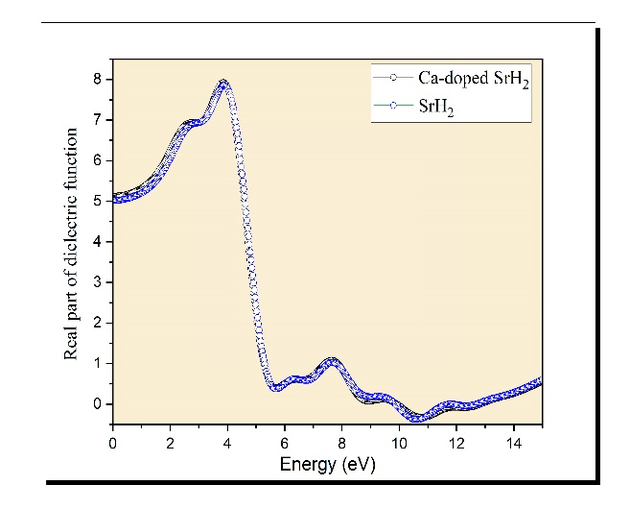
- (b)
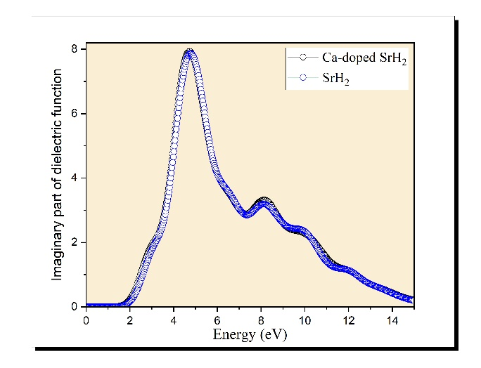

Fig4: a)real part, b) imaginary part of dielectric function of pristine SrH₂ and Ca-doped SrH₂

All other optical parameters, including the absorption coefficient, energy loss function, reflectivity, extinction coefficient, and refractive index, can be derived from the dielectric constants. The refractive index $n\left(ω\right)$ of the aforementioned compounds can be calculated using the following relation, which incorporates the computed values of the real part $ε_{1 }(ω)$ and the imaginary part $ε_{2}(ω)$ of the dielectric function:

$n\left(ω\right)= \frac{1}{\sqrt{2}}{[ \sqrt{ε_{1}^{2}\left(ω\right)+ε_{2}^{2}\left(ω\right)}+ε_{1 }(ω)]}^{\frac{1}{2}}$ (4)

The static refractive index $n\left(0\right)$, which is the refractive index at the zero-frequency limit, can be determined using the static dielectric function with the following formula:
$n\left(0\right)=\sqrt{ε_{1}(0)}$ (5)

The extinction coefficient can be determined by utilizing the calculated values of $ε_{1 }(ω)$​ and $ε_{2 }(ω)$​ for the aforementioned compounds, using the following relation:

$k\left(ω\right)= \frac{1}{\sqrt{2}}{[ \sqrt{ε_{1}^{2}\left(ω\right)+ε_{2}^{2}\left(ω\right)}-ε_{1 }(ω)]}^{\frac{1}{2}}$ (6)

The calculated values of the extinction coefficient $k\left(ω\right)$ and refractive index $n\left(ω\right)$ for the aforementioned compounds are crucial for analyzing the complex refractive index $N\left(ω\right)=n\left(ω\right)+ik(ω)$, which characterizes the propagation of electromagnetic waves within a material. A comprehensive understanding of the refractive index $n\left(ω\right)$ is essential for assessing the potential applications of optical materials in various devices. For instance, materials suitable for photovoltaic systems require high optical conductivity, a high absorption coefficient, low emissivity, and a high refractive index. The spectra of the refractive index $n\left(ω\right)$and extinction coefficient $k\left(ω\right)$, calculated using the $GGA-PBE$ approximation, are presented in Figures 5(a) and 5(b) for both pristine SrH₂ and Ca-doped SrH₂. The static refractive index $n\left(0\right)$values are approximately 2.24 for pristine SrH₂ and 2.26 for Ca-doped SrH₂. The maximum refractive index values $n\left(ω\right)$ are 2.91 for pristine SrH₂ and 2.92 for Ca-doped SrH₂. A comparable trend can be observed between the real part of the dielectric function, $ε_{1 }(ω)$ and the refractive index, $n\left(ω\right)$ as illustrated in Figures 4(a) and 5(a). Both spectra display an initial peak at low photon energies, suggesting strong interaction with incident photons at these energy levels. This peak is followed by a steady decline in both coefficients, which can be attributed to fluctuations in the material's response as photon energy increases. This behavior underscores the relationship between the dielectric function and the refractive index in defining the optical properties of the material. Similarly, the extinction coefficient, $k\left(ω\right)$ and the imaginary part of the dielectric constant, $ε_{1 }(ω)$ exhibit comparable profiles, as shown in Figures 5(b) and 4(b). Both the extinction coefficient and the imaginary component of the dielectric constant begin at a specific threshold energy. These threshold energies are approximately 1.39 eV for pristine SrH₂ and 0.61 eV for Ca-doped SrH₂. The maximum values of the extinction coefficient, denoted $k_{max}(ω)$, are 1.6880 for pristine SrH₂ and 1.6881 for Ca-doped SrH₂. After reaching these peak values, the extinction coefficient spectra $k\left(ω\right)$gradually decline towards unity.

(b)
(a)
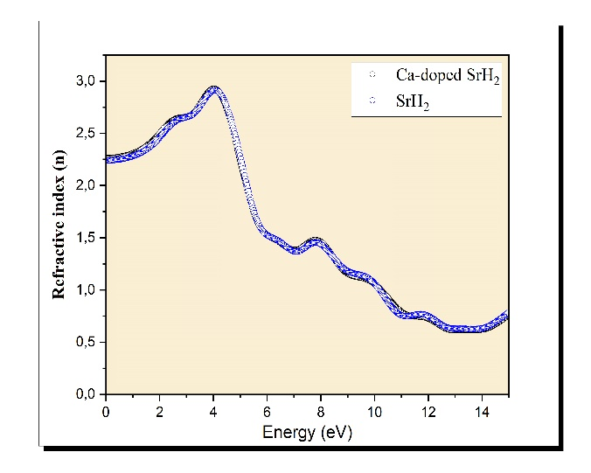
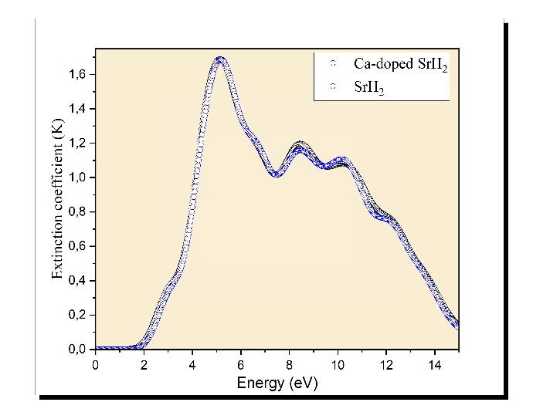

Fig5: a)Refractive index, b) Extinction coefficient of dielectric function of pristine SrH₂ and Ca-doped SrH₂

3.2.2 Absorption Coefficient, reflectivity, Loss function and conductivity

To explore the effect of calcium (Ca) doping on the optical properties of SrH₂ in greater detail, the absorption coefficient was calculated. This coefficient, which reflects the material's ability to absorb light at different photon energies, was derived using the previously computed values of the real $ε_{1 }(ω)$ and imaginary $ε_{2 }(ω)$ components of the dielectric function for both pristine and Ca-doped SrH₂. The absorption coefficient $α\left(ω\right)$ can be expressed using the following relation:
$α\left(ω\right)= \sqrt{2}ω{[ \sqrt{ε_{1}^{2}\left(ω\right)+ε_{2}^{2}\left(ω\right)}-ε_{1 }(ω)]}^{\frac{1}{2}}$ (7)

Figure 6(a) illustrates the calculated absorption coefficient spectra for both pristine and Ca-doped SrH₂. As expected, the absorption edge for Ca-doped SrH₂ is shifted towards lower energy values compared to the pristine material. This redshift in the absorption edge signifies an enhanced ability of the Ca-doped system to absorb photons across a wider spectral range, particularly within the visible light spectrum. The improved optical absorption properties of Ca-doped SrH₂ suggest its potential as an advantageous material for applications in solar energy harvesting and other optoelectronic devices. By broadening the absorption spectrum, Ca-doped SrH₂ can increase the efficiency of light absorption, making it more suitable for energy-related applications that require effective photon utilization. Calculations indicate that both pristine and Ca-doped SrH₂ exhibit transparency below their energy band gaps, as demonstrated in Figure 6(a). This transparency occurs because the energy of incident photons is insufficient to excite electrons from the valence band to the conduction band. The absorption spectra also reveal anisotropy in both pristine and Ca-doped SrH₂, reflecting the directional dependence of the absorption coefficient. The absorption coefficient is significantly affected by photon frequency, as this determines the electron transitions from the valence band ($VB$) to the conduction band ($CB$). Across the entire energy range from 0 to 14 eV, the absorption coefficient of pristine SrH₂ is higher than that of Ca-doped SrH₂, indicating that Ca doping slightly reduces the material's absorption capacity. Despite this reduction, both materials exhibit strong absorption in the ($UV$) region, suggesting their suitability for optoelectronic applications in this range. As highlighted in Figure 6(a), the maximum absorption coefficient values for pristine SrH₂ and Ca-doped SrH₂ are observed at approximately 10.46 eV and 10.35 eV, respectively, both in the UV region. The maximum absorption coefficients are approximately 1.82 × 10⁵ cm⁻¹ for pristine SrH₂ and 1.83 × 10⁵ cm⁻¹ for Ca-doped SrH₂. These findings underscore the potential of both pristine and Ca-doped SrH₂ for use in UV optoelectronic devices, where their strong absorption properties can be effectively utilized. the calculated values of the complex dielectric function $ε\left(ω\right)$can also be utilized to determine the frequency-dependent reflectivity $R\left(ω\right)$. The reflectivity $R\left(ω\right)$ is an important optical property, particularly for assessing the material's ability to reflect incident light at various frequencies. This parameter can be determined using the formula below:
$R\left(ω\right)= {\left|\frac{\sqrt{ε(ω)}-1}{\sqrt{ε(ω)}+1 }\right|}^{2}$ (8)

Figure 6(b) illustrates the frequency-dependent reflectivity spectra $R\left(ω\right)$for both pristine SrH₂ and Ca-doped SrH₂. As shown in the figure, the static reflectivity values (at zero frequency) are approximately 0.150 for pristine SrH₂ and 0.146 for Ca-doped SrH₂. The spectra reveal that Ca-doped SrH₂ exhibits higher reflectivity compared to pristine SrH₂ across the frequency range. The most prominent peaks in the reflectivity spectra for both materials are observed in the energy range from 4 to 12 eV, with the maximum reflectivity values reaching 0.3262 for pristine SrH₂ and 0.3267 for Ca-doped SrH₂.

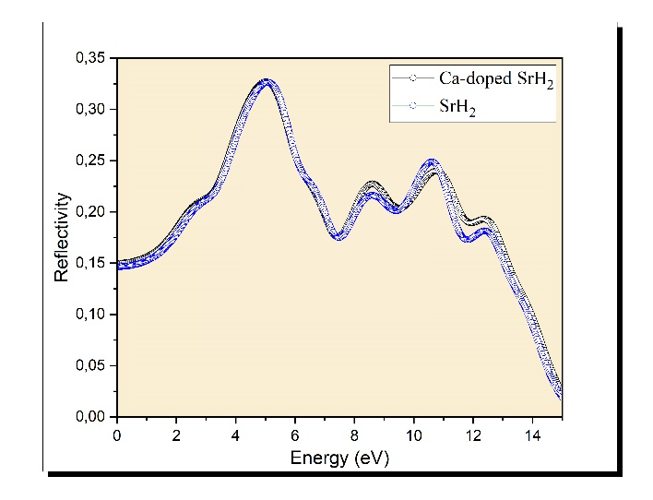
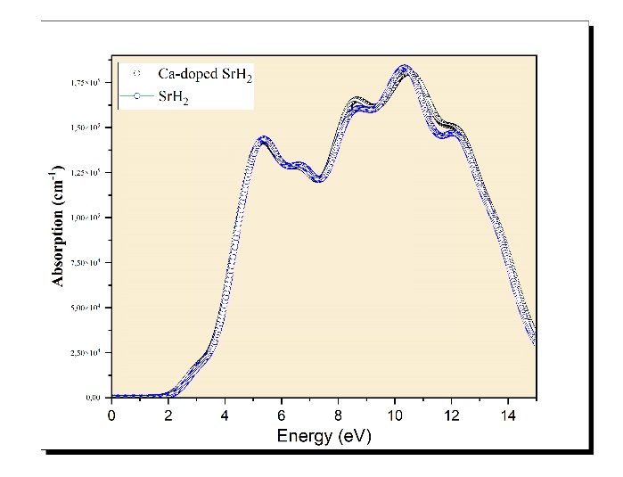
(b)
(a)

Fig6: a) Absorption, b) Reflectivity of pristine SrH₂ and Ca-doped SrH₂

The energy loss function $L\left(ω\right)$ quantifies the energy loss experienced by high-energy electrons as they pass through a material. It provides insight into the material's interactions with fast-moving electrons and can be computed from the complex dielectric function values using the following relation:
$L\left(ω\right)=\ln\left(-\frac{1}{ε\left(ω\right)}\right)$ (9)

Figure 7 displays the calculated spectra of the energy loss function $L\left(ω\right)$ across the energy range from 0 to 14 eV. The energy loss function offers significant insights into the interactions between incident photons and the material's electronic systems. It is notable that there is a corresponding reduction in the reflectivity spectra at these same energy points. The energy loss function $L\left(ω\right)$ exhibits prominent peaks at 13.89 eV and 13.81 eV for SrH₂ and Ca-doped SrH₂, respectively, signifying plasma resonance at these plasma frequencies.

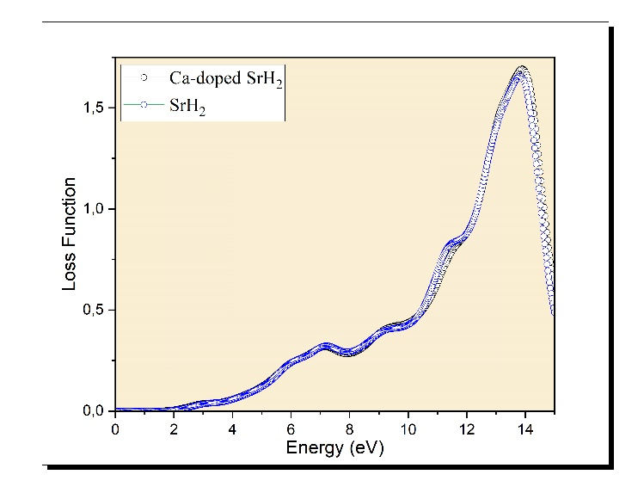

Fig7: Loss function of pristine SrH2 and Ca-doped SrH₂.

Figures 8(a) and 8(b) illustrate the real and imaginary parts of the optical conductivity σ\sigmaσ for both pristine SrH₂ and Ca-doped SrH₂ across a range of energies.
In Figure 8(b), the imaginary part of the conductivity reveals notable differences between the two materials. For pristine SrH₂, the curve displays pronounced negative peaks around 4 eV and beyond, indicating significant energy absorption or polarization effects. In contrast, the Ca-doped SrH₂ shows reduced intensity in these features, suggesting that calcium doping diminishes the absorption at these specific energy levels. This reduction is likely due to alterations in the electronic structure caused by doping, which shifts the energy levels involved in optical transitions.

Figure 8(a) depicts the real part of the conductivity, where distinct differences are also observed due to calcium doping. Pristine SrH₂ exhibits a sharp peak around 4.88 eV, indicating strong conductivity at this energy. In the Ca-doped sample, this peak becomes broader and slightly less pronounced, suggesting increased scattering and a more diffusive electronic structure. Additionally, at higher energies (above 11.98 eV), the conductivity in the doped material is consistently lower than in the pristine sample, reflecting a decrease in the number of free carriers or available states for conduction.

(b)
(a)
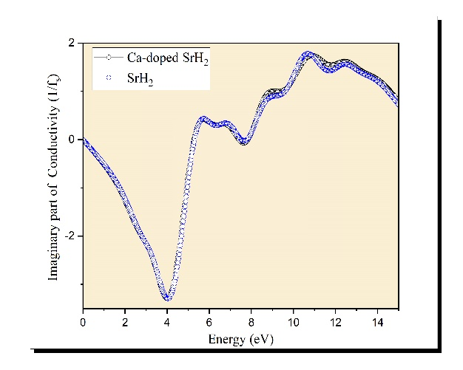
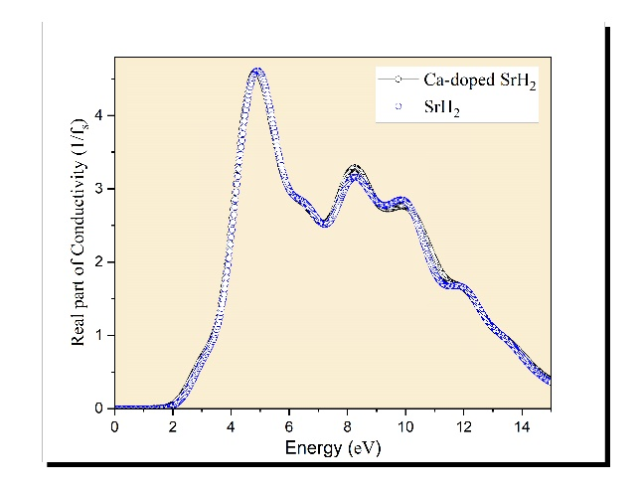

Fig8: a) Real part, b) Imaginary part of the conductivity of pristine SrH₂ and Ca-doped SrH₂

4. Conclusion

This research offers a thorough examination of the electronic and optical properties of both pristine and Ca-doped SrH₂.utilizing first-principles calculations based on $DFT$. The results indicate that calcium doping notably modifies the electronic structure of SrH₂, leading to an increase in the band gap from 1.3 eV to 1.6 eV. This widening of the band gap corresponds to a reduction in intrinsic conductivity, as evidenced by the decreased real part of the optical conductivity at higher energies. The introduction of calcium also enhances the density of states in the conduction band, shifting the absorption edge to lower energies and improving photon absorption efficiency in the visible spectrum. Additionally, the doping effect is observed as a slight increase in the static dielectric constant and refractive index, reflecting altered optical behavior. Enhanced reflectivity and absorption characteristics suggest that Ca-doped SrH₂ may exhibit superior performance in the $UV-visible range$. These findings position Ca-doped SrH₂ as a promising candidate for optoelectronic applications, such as solar cells and photodetectors. Overall, calcium doping proves to be an effective method for fine-tuning the electronic and optical properties of SrH₂, thereby expanding its potential applications in advanced material technologies.

